Awk Documentation
- Print all the First Names.

Awk ‘{print $1}’ AwkLab.data

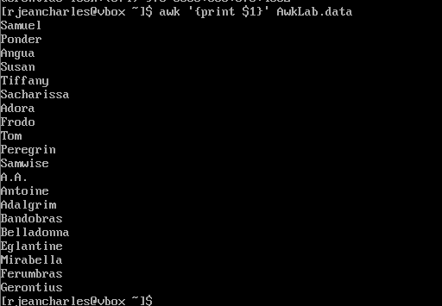
Break Down Command

Awk : read the file
‘ ‘ : the quotes prevent the shell from interpreting special characters
{print $1} : This is the action. It indicates taking every first element of each lines and print it.
AwkLab.data : The target file that contains the data.

- Print phone numbers for Tom and Frodo after their names
Awk -F: $1==”Frodo Baggins” || $1==”Tom Bombadil”{print $1 “\t” $2}’ AwkLab.data
Break Down Command
Awk : command to read within the file
-F: : It informed awk that the columns are separated by colon instead of white space
$1: Refers to the content on the first position in the line

== : it does a comparison. It checks for a specific match

”Frodo Baggins” : The string to search for within the file

|| : or operator that allows command to return a true result if both side matches

$1==”Tom Bombadil” : Same details as precedent except that is the second condition to verify with the first field

{print $1 “$1 “\t” $2}’ : This the execution instructions

{ } : Bracket that prevents to read the special characters within the action block
print : indicate to print the data in question
$1 : print the data on the first field of the line
“\t” : create space between the data
$2 : print value of second field on the line
AwkLab.data : The file containing the data

- Print Peregrin’s full name and phone number area code only.
awk -F: $1”==Peregrin Took” { split($2,a, “[()]”): print $1 “\t” a[2] }’ AwkLab.data
Break Down Command
Awk : command to read within the file
-F: It informed awk that the columns are separated by colon instead of white space

$1 : refer to the first column of the data
== comparison operator looking for if it matches the following string
“Peregrin Took” : Specific string that we are looking for.
{ } : Containing the execution part
split ($2,a, “[()]”)
$2 : look for second column
[()] : split when encounter parenthesis

print : instructions to print data that matches the indication
$1: Print first column value on the line
“\t” : create space between data
a[2]: print second element of array which is the area code
$2 : print second column value on the line
AwkLab.data : Target file containing data.

- Print all phone numbers (full number) in the 123-area code along with the names

awk -F: ‘$2~ /123/ {print $1 “\t” $2}’ AwkLab.data
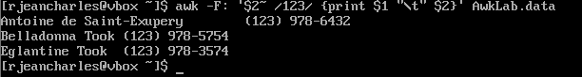
Break Down Command
Awk : command to read within the file

-F: It informed awk that the columns are separated by colon instead of white space

‘ : it indicates to not interpret the symbols inside the quotes.

‘$2 : refers to value on second column
~ : this is a match operator. It indicates that the following patterns is contained in this column

/123/ : indicates to search for these numbers in the second column

{ } : Contains the action that must be executed
print : indicate to print out data
$1 : print content on first column
“\t” : create space between data
$2: print data value of the second field of the line

AwkLab.data : Target file containing data.

5. Print all Last names beginning with either a T or D (careful of middle
names!)
awk -F: ‘{ n = split ($1, a, “ ”) if (a[n] ~ /^[TD]^/ {print a[n]}’ AwkLab.data
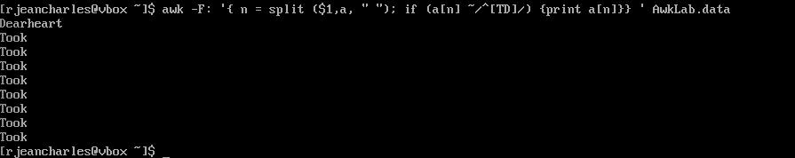
Break Down Comment
Awk : command to read within the file
-F: It informed awk that the columns are separated by colon instead of white space
’[ :]’ : this defined that the column is separated by a space or colon.
n = split ($1,a , “ ”) : take consideration of first column, split name using array called
n : is total number of characters created
a[n] : refers to last name
if : verify condition
~ : Match pattern that come after
~ : Match operator that indicate the column contains the following data
/^[TD]^/ : indicates awk to look for T or D uppercase inside the column.
{ } : contain the instructions
{print a[n]} : print if the second field contains an T or D
AwkLab.data : Target file containing data.

- Print all first names containing four or less characters.

Awk -F’[ :]’ ‘length($1) <=4 {print $1}’ AwkLab.data
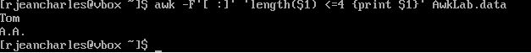
Break Down command
Awk : command to read within the file
-F : It informed awk that the columns are separated by colon instead of white space
’[ :]’ : It indicated a new column might start a space or a colon.
‘length($1) : count the number of characters in a string.
< =4 : Comparison Operator for “Less than or equal to.”

{ } : it contains the directions
print $1: If the length of the first column is 4 or fewer characters, print the value

AwkLab.data : Target file containing data.

- Print the first names and area codes of all those in the 916 area code.
awk -F’[ :()]’ ‘$4 == “916” {print $1, $4} AwkLab.data
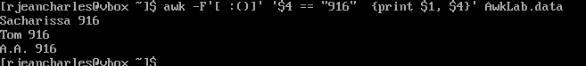
Break Down Command
Awk : command to read within the file
-F : It informed awk that the columns are separated by colon instead of white space
’[ :()]’ : It indicated a new column might start a space or a colon.
‘$4 : Refers to the fourth column created by the separators above.
== : The exact Match operator
“916” : The specific string the command looking for.
{ } : contains the action
print : print the output
$1, $4 : print the first column and the fourth column
, : insert the space of field separator between the data.
AwkLab.data : Target file containing data.

8. Print Sacharissa’s campaign contributions following her name. Each
value should be printed with a leading dollar sign, e.g., $250 $100 $175.
awk -F’[ :()]’ ‘$1 == “Sacharissa” {print$1, “$” $7, “$” $8, “$” $9}’ AwkLab.data
Break Down Command
Awk : command to read within the file
-F : It informed awk that the columns are separated by colon instead of white space
’[ :()]’ : It indicated a new column might start a space or a colon.
‘$1: Refers the first column
== : comparison operator
“Sacharissa” : specific string that we are looking for
{ }
print $1 : Prints name “Sacharissa”
“$” $7 : Prints a literal $ sign as string followed by value in seventh column
“$” $8 : Prints a literal $ sign as string followed by value in 8th column
“$” $9 : Prints a literal $ sign as string followed by value in 9thcolumn
AwkLab.data : Target file containing data.

9. Print last names followed by a comma and the phone number. Be
careful of the last name’s format.
awk -F: ‘{ n = split($1,a, “ ”) ; print a[n] “, “ $2}’ AwkLab.data
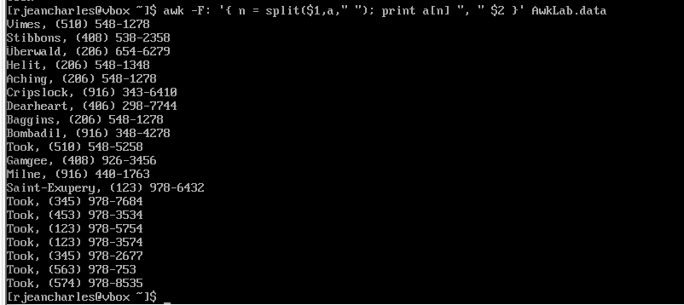
Break Down Command
Awk : command to read within the file
-F: : It informed awk that the columns are separated by colon instead of white space
{ } : contains what should be executed
n = split ($1,a , “ ”) : take consideration of first column, split name using array called
n : It is total number of parts in the name
a[n] : refer to the last element of the array
print : print the data
a[n] : print the last name
“, “ : string that create a space after the comma
$2 : print the value of the second column
AwkLab.data : Target file containing data.

10. Print the first and last names of those who contributed more than $110
in the last month. Make sure to include their last month contribution
amount after the name
awk -F’:’ ‘$5 > 110 {PRINT$1 “$”$5}’ AwkLab.data
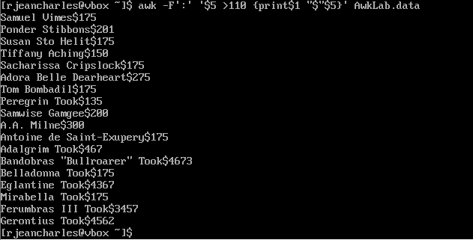

Breakdown command
Awk : command to read within the file
-F’:’ : It informed awk that the columns are separated by colon instead of white space
$5 : refers to the 5th column
> : comparaison operator
110 : The value to compare
{ } : Contains the direction that should be executed by the command awk
print : print the output
$1 : print the value of the first column
“$” : string that print the dollar sin
$5 : print the value of the fifth column
AwkLab.data : Target file containing data.

11. Print the last names, phone numbers, and first month contribution of
those who contributed less than $150 in the first month.
awk -F’:’ ‘$3 < 150 {split($1,a,” “); printf “%s, %s, $%s\n”, a[2] $2, $3}’ AwkLab.data
Break Down command
Awk : command to read within the file
-F’:’ : It informed awk that the columns are separated by colon instead of white space
$3 : refers to the 3th column
< : comparison operator less than
150 : The value to compare
{ } : Contains the direction that should be executed by the command awk
{split($1,a,” “); : this takes the first column separate it into pieces and store those pieces in the arrayed a.
Printf : This is the format of the result expected
%s , %s , $%s\n : Holding string with placeholder for the text and new line character at the end.
a[2], $2, $3 : Placeholders for second and third column
AwkLab.data : Target file containing data.

12. Print the first names and contribution of those who contributed be-
tween $10 and $200 in the first month.
Awk –F’:’ ‘$3 >=10 && <200 {split$3($1,a,” “); print a[1], “$”$3}’ AwkLab.data
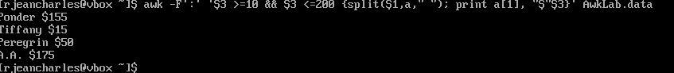
Breakdown Command
Awk : command to read within the file
–F’:’ It informed awk that the columns are separated by colon instead of white space
‘$3 >=10 : comparison of third column to see if the value is greater or equal to 10.
&& : logic AND that indicate to execute the command for both side.
<200 : check if the third column is less than 200
{ }: Contains the direction that should be executed by the command awk
split$3($1,a,” “) : break the content in the first column by using the space
print : Print output
a[1]: Print the first name only since it breaks the first column in two parts
“$”$3: print a dollar string following by the value in the third column
AwkLab.data : Target file containing data.

13. Print the first name, last names and total contributions of those who contributed less than $700 over the three-month period.
awk -F’:’ ‘{total=$3+$4+$5} total<700 {split($1,a,” “); print a[1], a[2], “$” total}’ AwkLab.data
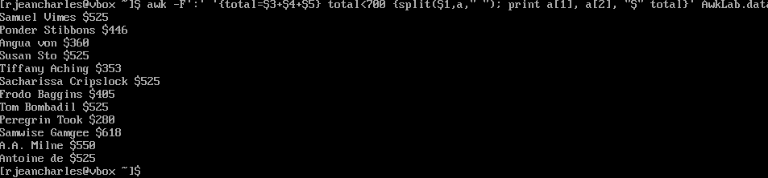
BreakDown Command
awk : command to read within the file
-F’:’ It informed awk that the columns are separated by colon instead of white space
{total=$3+$4+$5} : stores the sum of 3rd 4th and 5th column.
total<700 : checks if the sum is less than 700
split($1,a,” “): separate the first column at the space
print a[1], a[2], “$” total}’ : Print first name, last name, the string dollar $ and the sum.
AwkLab.data : Target file containing data.

14. Print the first names and first letter of the last name, and average contribution of those who had an average contribution of more than $300
awk -F’:’ ‘{avg=$3+$4+$5} avg>300 {split($1,a,” “); print a[1], substr[2,1,1], “$” avg}’ AwkLab.data

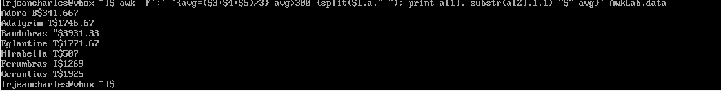
Break down command
awk : command to read within the file
-F’:’ It informed awk that the columns are separated by colon instead of white space
{avg=$3+$4+$5}/3 : Add 3rd, 4th and 5th value and divide by 3 to have the average
avg>300 : Verify if average value is greater than 300
split($1,a,” “) : Split the first column in two parts by using the space
print a[1] substr a[2],1,1], “$” avg} : Print first name contained in the first array, print only the first character from the last name.
AwkLab.data : The file containing the data

15. Print the last name and area code of those not in the 916 area code.
awk -F’:’ ‘{ area = substr(2$,2,3): if ( area !=”916”{split($1,a,” “); print a [2], area}}’ AwkLab.data 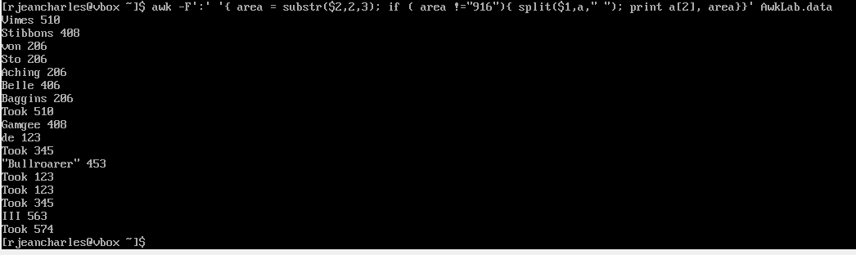
Breakdown command
Awk : : command to read within the file

-F’:’ It informed awk that the columns are separated by colon instead of white space
{ } : Contains what to execute
area : Temporary container to save the digits.
area = substr($2,2,3): look at the second column start at the second character and take the third one and store them into area
if : condition to be executed the statement in the parenthesis is true
( area !=”916”) Condition is to verify if the area container of the digits is not equal to 916
{split($1,a,” “): Grab the first column and split it in two pieces and place them into array.
print a [2], area : output last name and area code
AwkLab.data ; Target file that contains the data.

16. Print each record preceded by the number of the record.
awk ‘{print NR $0}” AwkLab.data
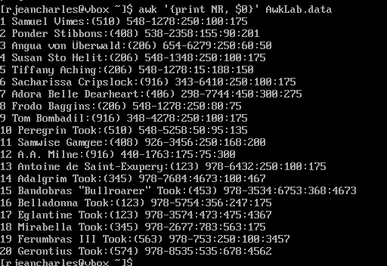

awk : Command to read within the file
{ } : Contains what suppose to be executed
Print : print output
NR : Built-in variable that means Number of Records.
$0: variable representing the entire columns
AwkLab.data : Target file containing data

17. Print the name and total contribution of each person.
awk -F’:’ ‘{total=$3+$4+$5; print $1, “$” total} AwkLab.data

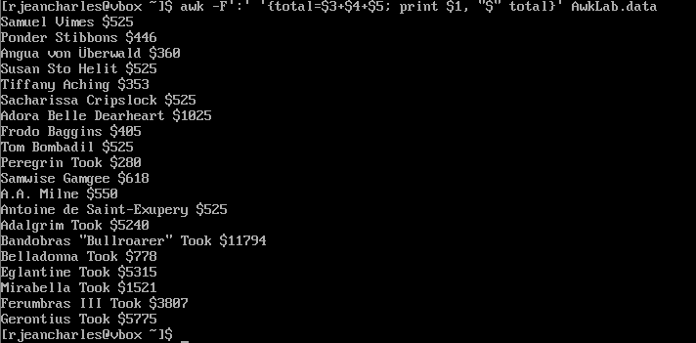
awk : Command to read within file
-F’:’ : It informed awk that the columns are separated by colon instead of white space
{ }: contain command that should be executed
total=$3+$4+$5 : Do the sum of 3rd, 4th, 5th column and stores the results in total variable
print $1, “$” total : Print first column with dollar sign following by a space that separate them
AwkLab.data : Target file containing data

18. Add $10 to Tiffany Aching’s first contribution and print her full name and first contribution.
awk-F’:’ ‘$1== “Tiffany Aching” { $3 +=10; print $1, “$”$3 }’ AwkLab.data
awk : Command to read within file
-F’:’ It informed awk that the columns are separated by colon instead of white space
$1== “Tiffany Aching : condition to verify if first column match the string name in question
{ } : contains command that should be excute
$3 +=10 : Select value of third field and add 10 to it
print $1, “$”$3 : output the first column content which is the name, the dollar string and the new value of the third column
AwkLab.data : Target file containing data

19. Change Samwise Gamgee’s name to Sean Astin
awk -F’:’ ‘{ if($1==”Samwise Gamgee”) $1=”Sean Astin” print }’ OFS=‘:’ AwkLab.data
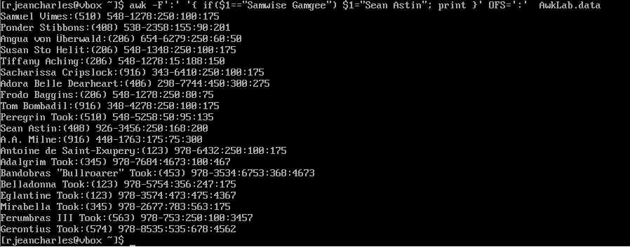
awk -F’:’ ‘{ if($1==”Samwise Gamgee”) $1=”Sean Astin” print }’ OFS=‘:’ AwkLab.data
awk : Command to read within file
-F’:’ It informed awk that the columns are separated by colon instead of white space
$1== “Samwise Gamgee” : condition to verify if first column match the string name Samwise Gamgee in question
$1== “Sean Astin” : condition to verify if first column match the string name Sean Astinin question and replace the old name by this new one.
{ } : contains command that should be excute
Print : Verify if name is update to change it.

20. Write an awk script to do the following (MUST be an awk script not
just a bash script or commands on the command line)
(a) Prints first name of the all the Tooks followed by their total campaign contributions
(b) Print the full names and contributions of anyone who contributed
between $10 and $200 in the last contribution
(c) Prints the full names and average contribution of those who con-
tributed less than $300 on average

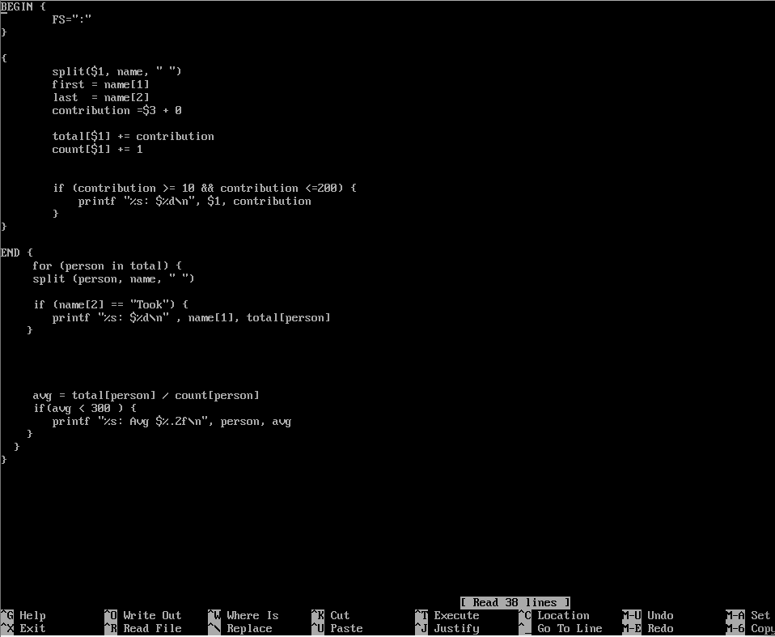
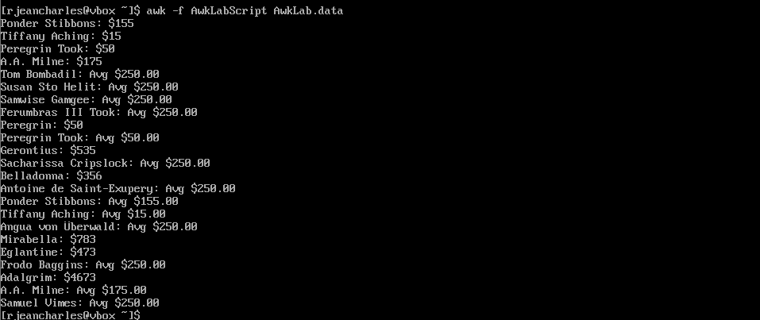

Break down command
BEGIN : Start before data can be read
FS=“:” : Field separator for a column.
Split($1, name, “ ”) : Break down the first column into array
first = name[1] : Store first name
last = name[2] : Store last name
Contribution = $3 + 0 : grab value of third column. Add 0 to make sure it is a number not a string
Total[$1} += contribution :
Count [$1] += 1 :
If : Check if contribution is between 10 and 200. If the condition is true print the person’s name and the amount.
for ( person in total) : look for every name
avg = total [person] / count[person] : Calculates the average contribution for that individual.

